

# Practices for Secure Software Report

Table of Contents

Document Revision History 3

Client 3

Instructions 3

Developer 4

1. Algorithm Cipher 4

2. Certificate Generation 4

3. Deploy Cipher 4

4. Secure Communications 4

5. Secondary Testing 4

6. Functional Testing 4

7. Summary 4

8. Industry Standard Best Practices 4

## Document Revision History

| **Version** | **Date** | **Author** | **Comments** |
| --- | --- | --- | --- |
| **1.0** | **18 April 2025** | **Christina Jimenez** | **Editing** |

## Client



## Developer

Christina Jimenez

## Algorithm Cipher

AES is widely regarded as a secure and efficient encryption algorithm. I believe that this cipher is best suited for the needs of Artemis Financial. It offers strong protection against various attacks to which Artemis Financial is susceptible, including brute force and cryptanalysis. AES uses a symmetric encryption method, specifically splitting data into blocks of 128 bits each, which allows for more secure encryption. Implementing AES with a key size of 256 bits enhances security, making it extremely difficult for attackers to compromise encrypted data since there are approximately 1.1 x 10^77 possible combinations (What is the Advanced Encryption Standard, 2024). This makes AES highly suitable for encrypting sensitive financial data.

To ensure high encryption strength one can use random numbers. Random numbers enhance encryption strength by introducing unpredictability. AES keys are generated using Cryptographically Secure Pseudorandom Number Generators (CSPRNGs) (Secure Random Generators). AES employs symmetric keys, meaning the same key is used for both encryption and decryption. This makes AES faster and more efficient for encrypting large volumes of data compared to asymmetric encryption, which uses a public key for encryption and a private key for decryption. Although asymmetric encryption is generally more secure, it is significantly slower, making it unsuitable for Artemis Financial.

AES was first proposed by NIST in 1997 as a replacement for the outdated Data Encryption Standard (DES), which had become vulnerable to attacks (Smid, 2021). After extensive development, AES was officially established as the encryption standard in 2001, replacing DES (Smid, 2021). Today, AES is the gold standard for encryption and is widely used across various industries due to its combination of high security, efficient performance, and adaptability to different encryption needs.

## Certificate Generation

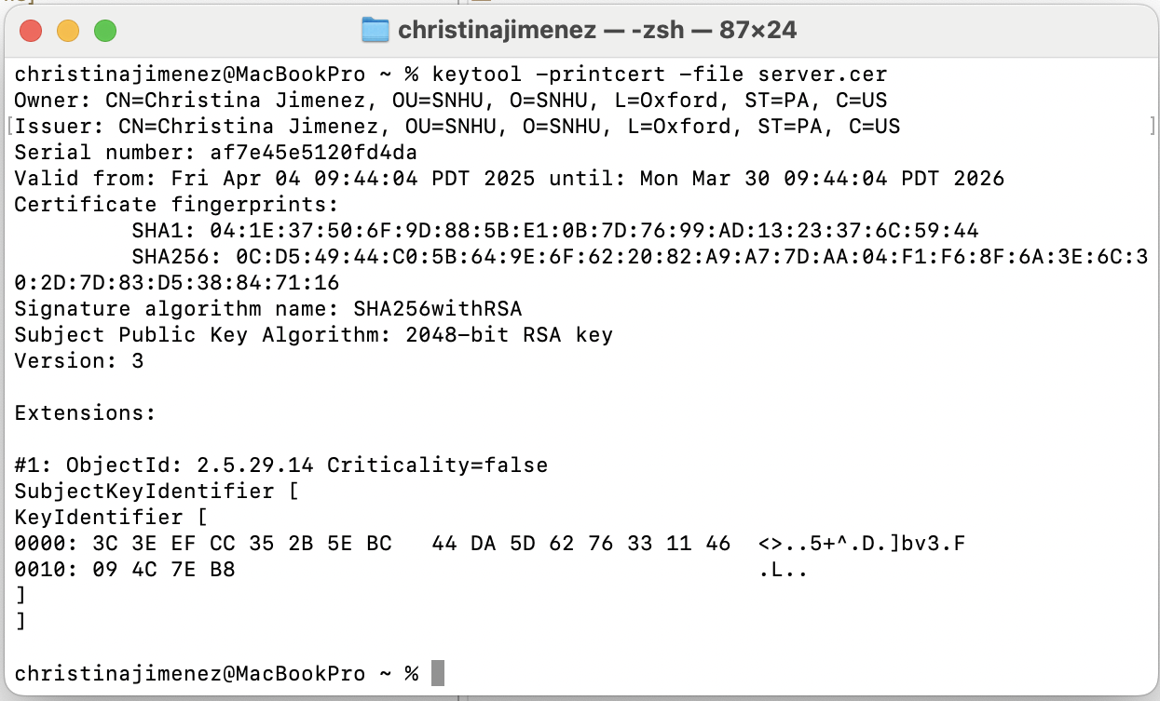

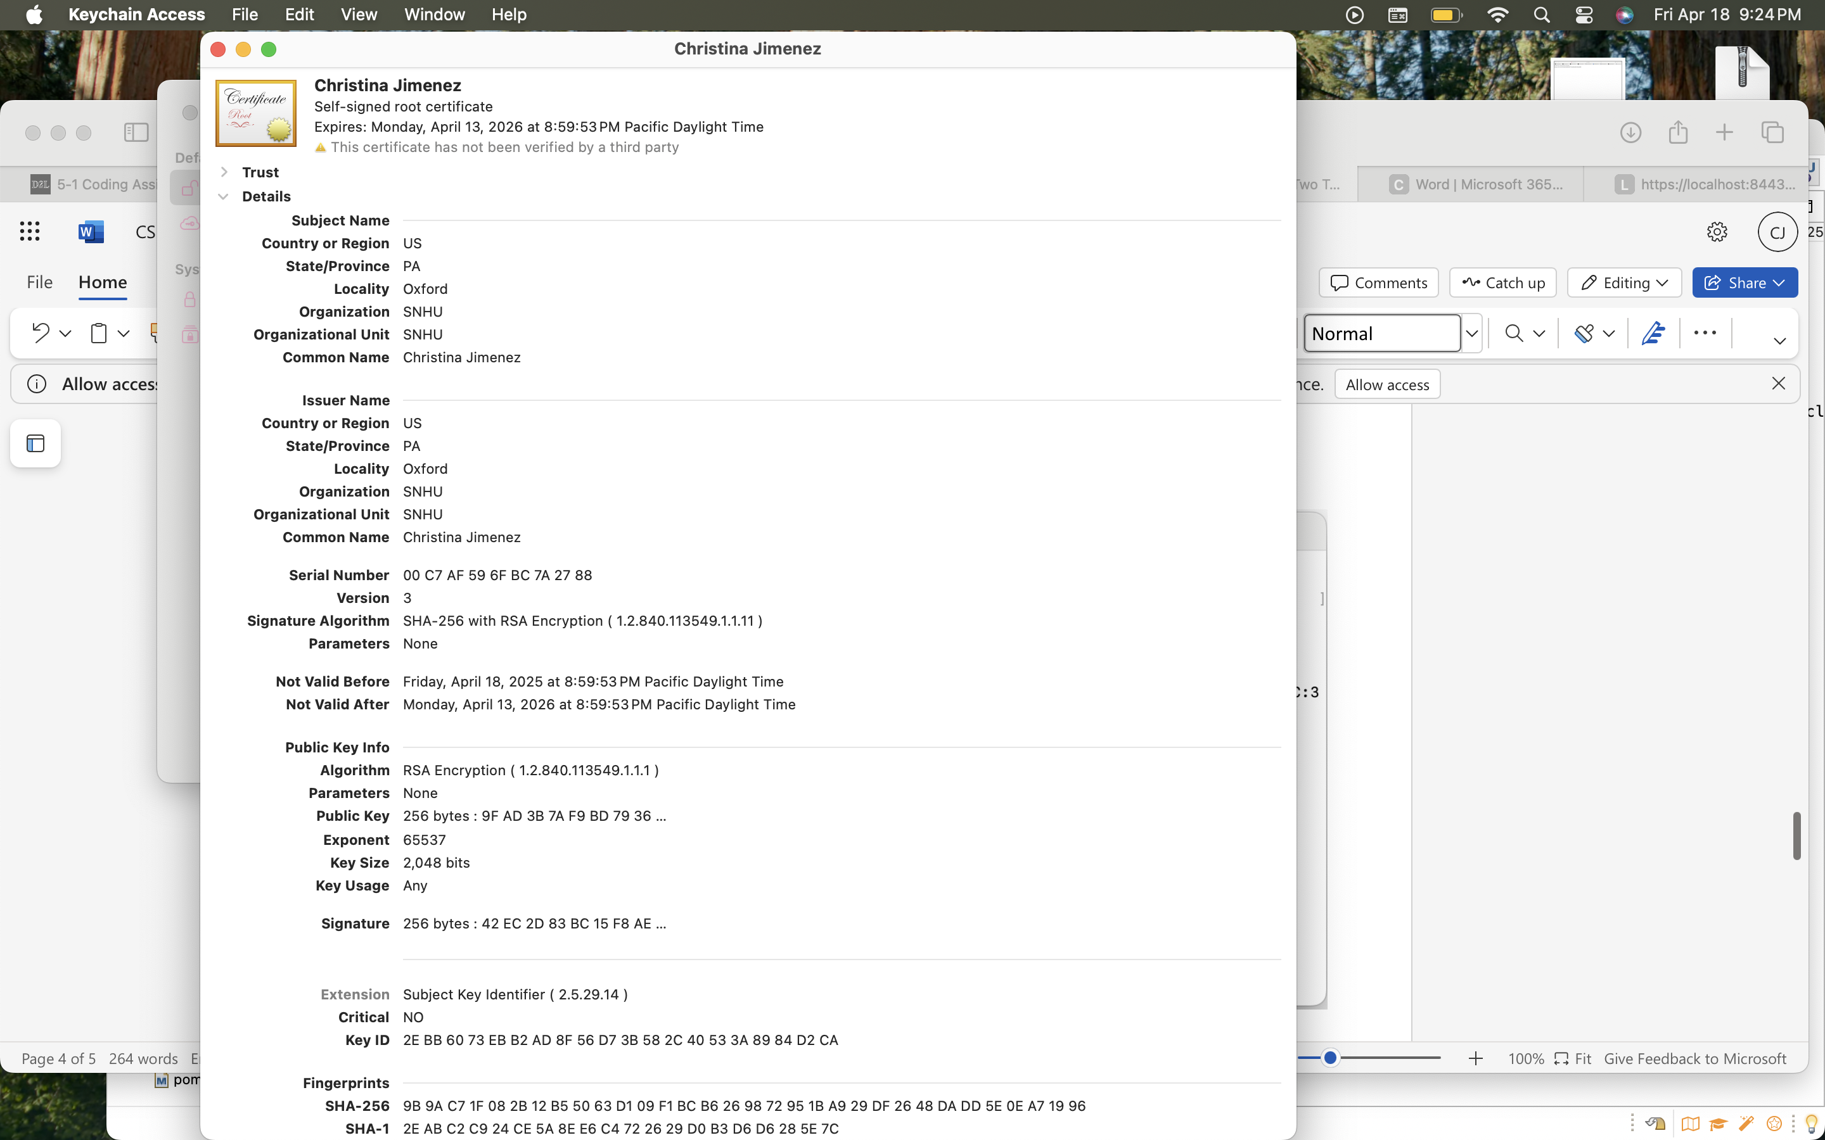

## Deploy Cipher

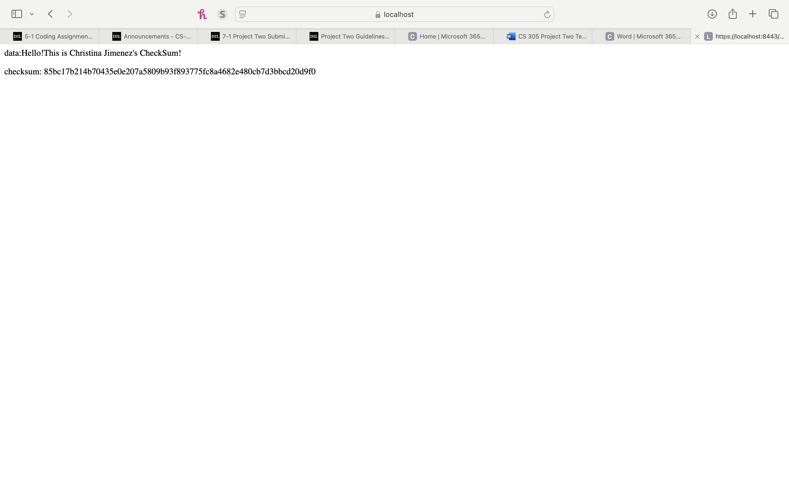

## Secure Communications

Insert a screenshot below of the web browser that shows a secure webpage.

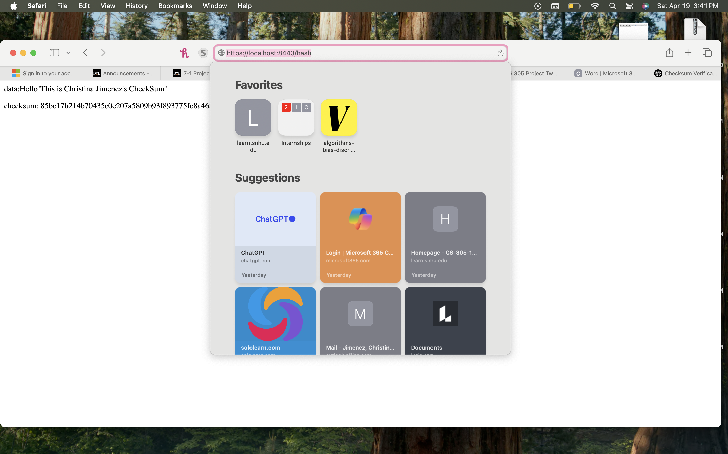

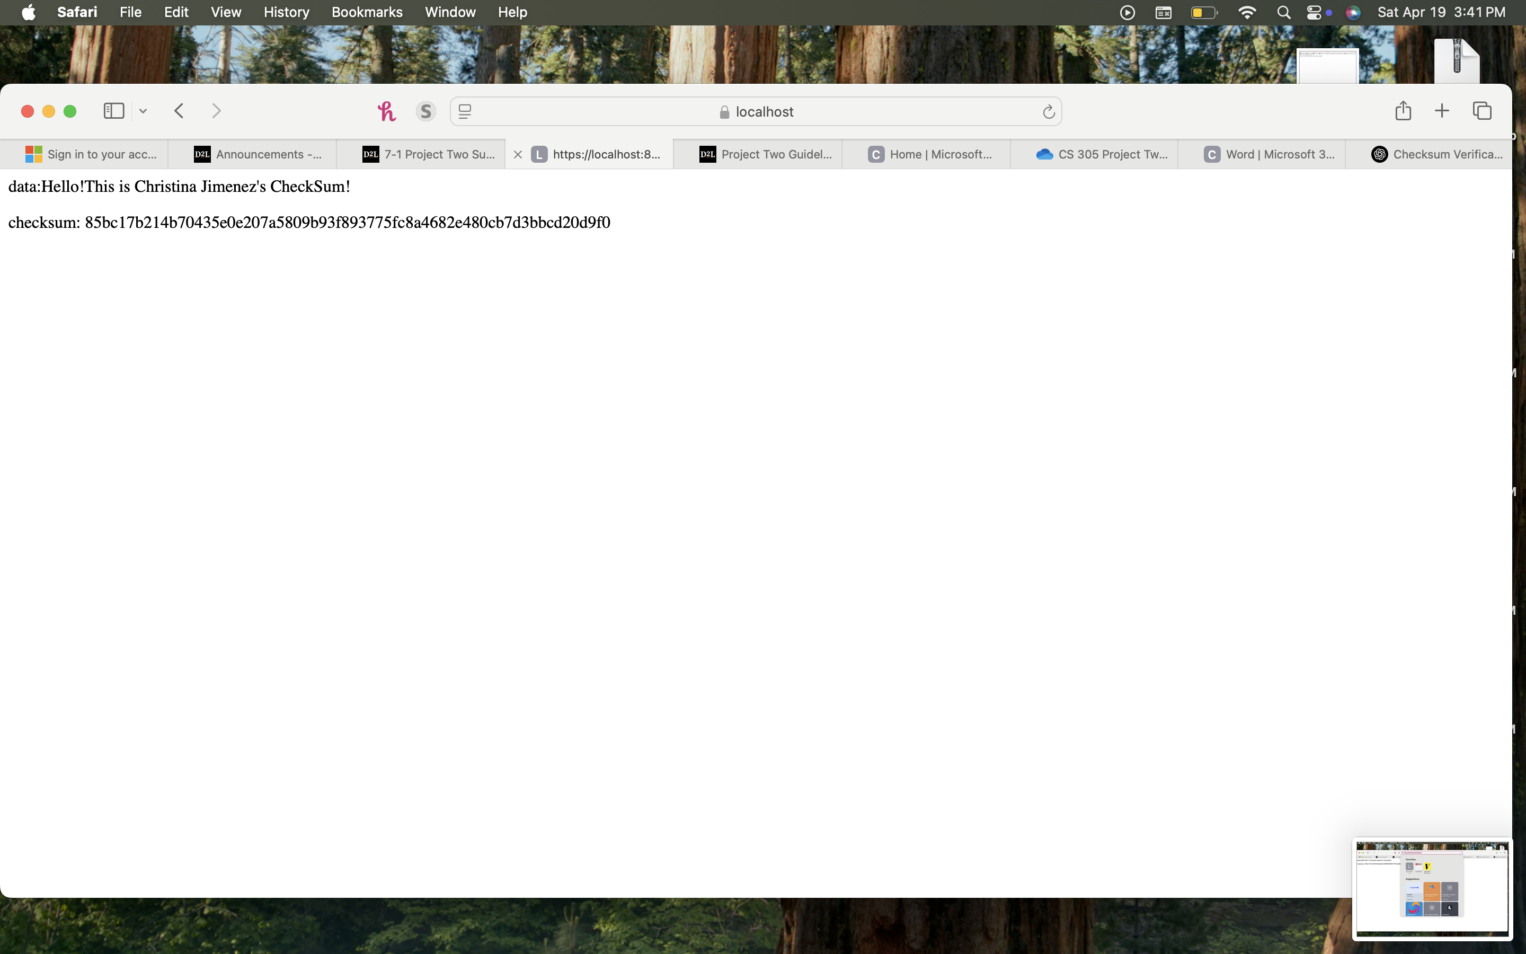

## Secondary Testing

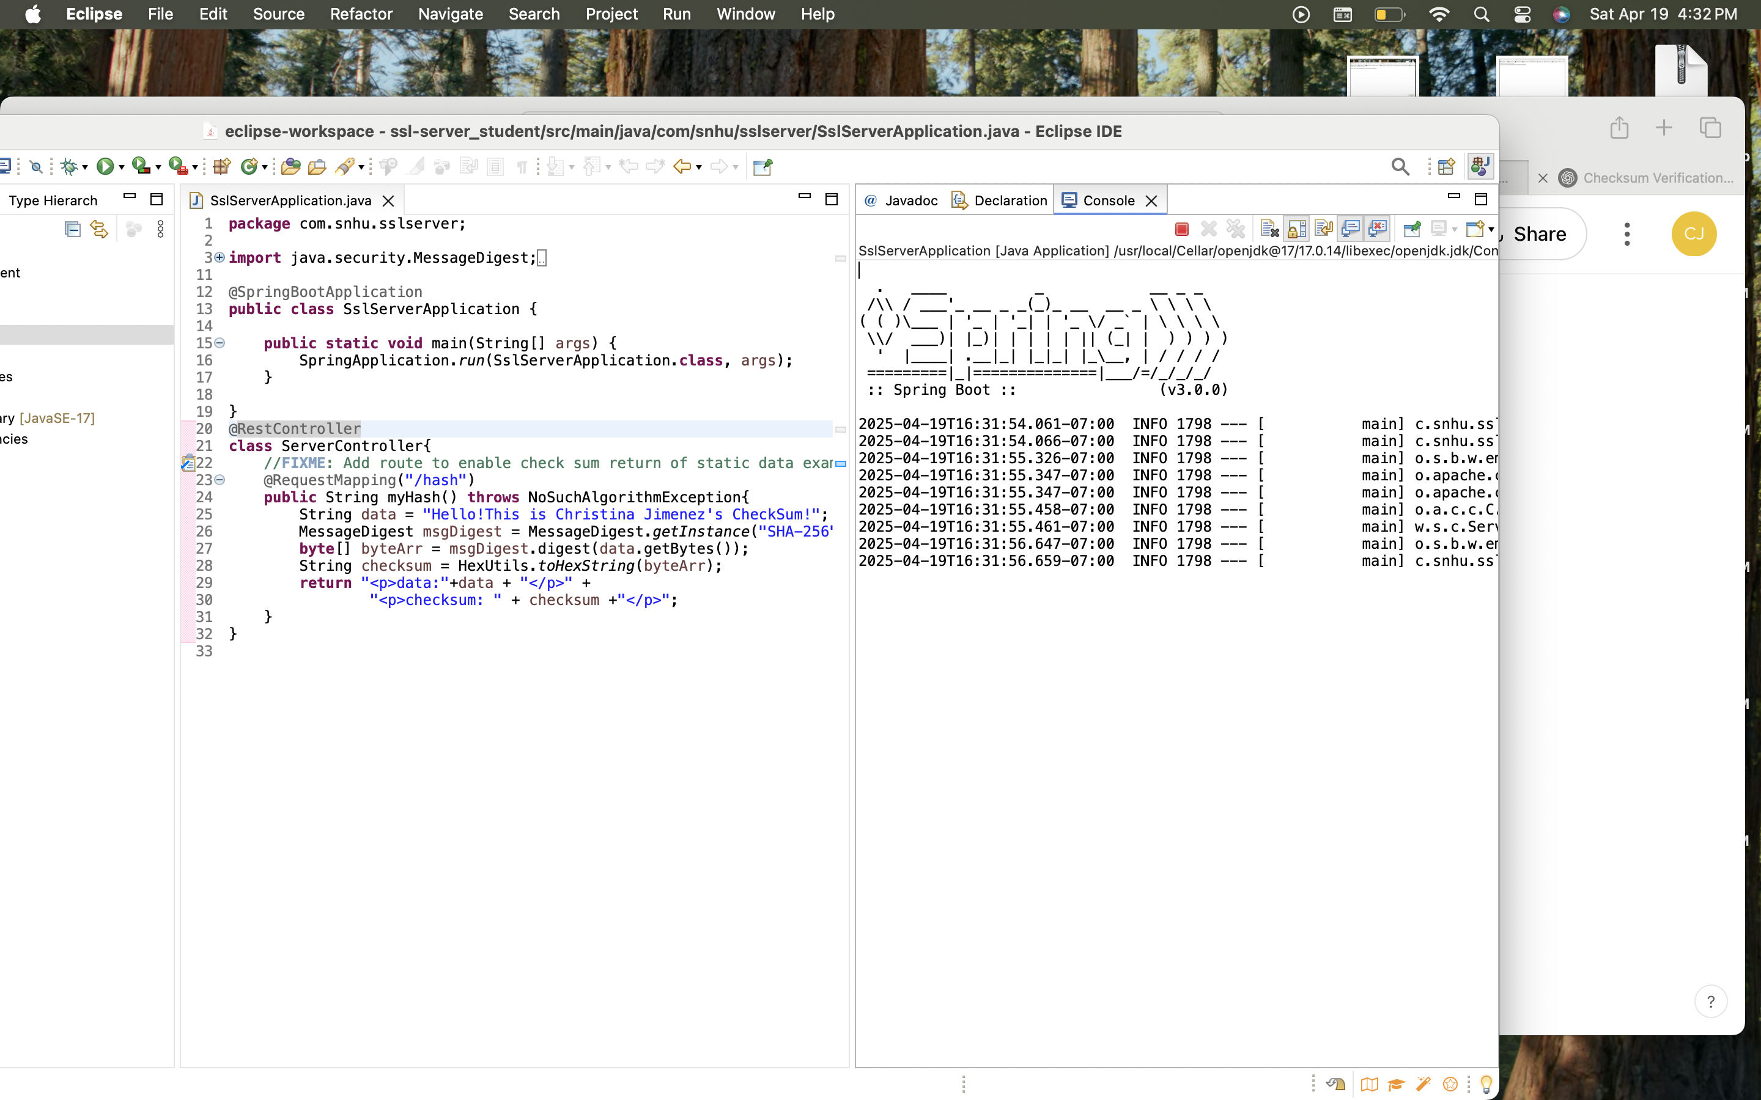

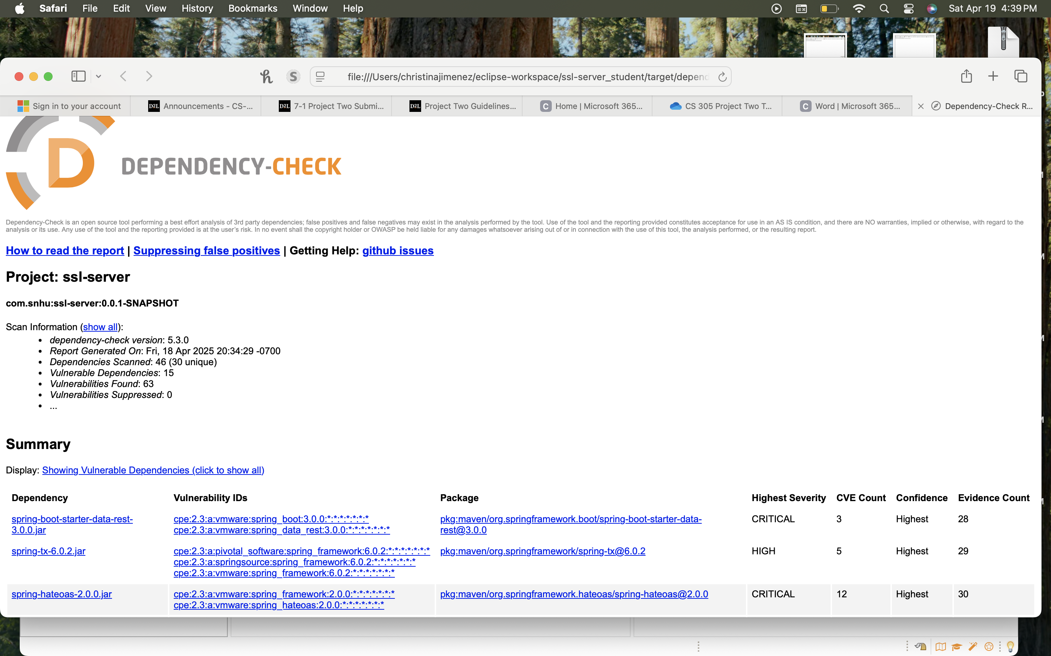

## Functional Testing

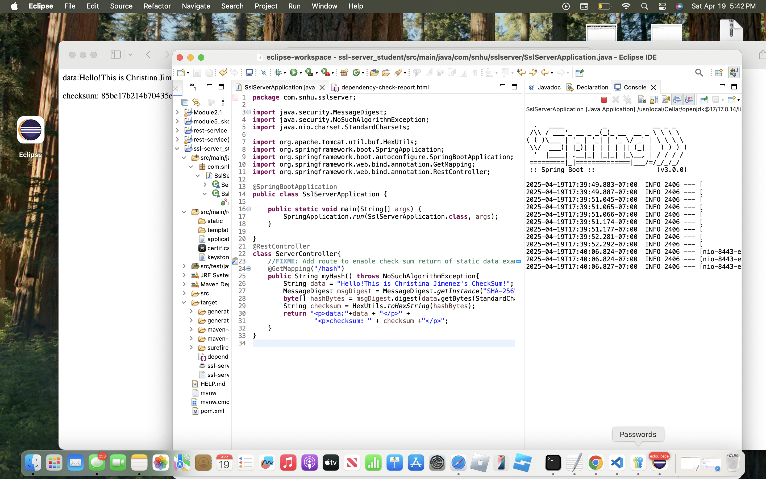

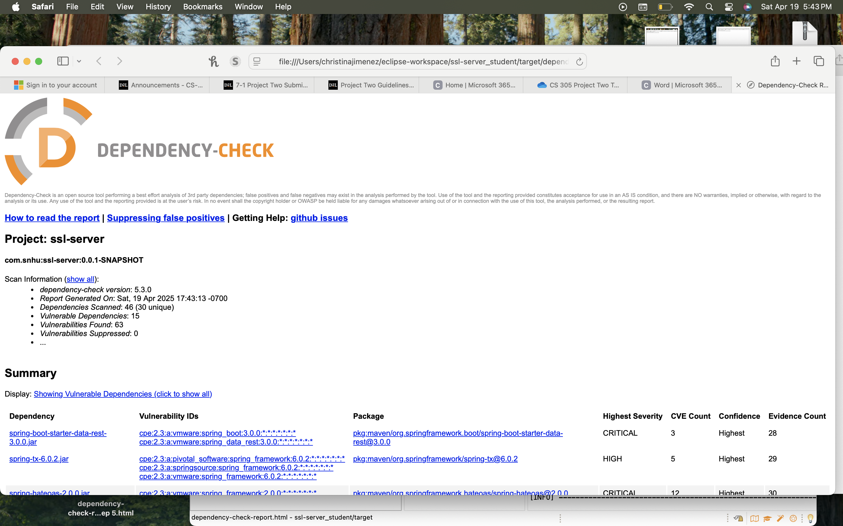

## Summary

During the refactoring process, I addressed several key areas of software security. First, I introduced cryptographic integrity through the use of SHA-256 hashing within a new endpoint that returns a checksum of static data. This demonstrates secure data representation and the correct application of cryptographic algorithms. Additionally, the implementation follows best practices for input handling by using standardized encoding (UTF-8) and reliable Java security libraries. This refactoring aligns with multiple components from the vulnerability assessment process, such as code quality, secure coding practices, and cryptography.

My approach to adding security involved a layered strategy for added defense. I began by reviewing the application’s entry points and refactored them to ensure that all external interactions were clearly defined and controlled. By adding the checksum route using SHA-256, I introduced a cryptographic layer that serves as an example of secure data verification. This is especially beneficial when dealing with financial information, such as Artemis Financial seeks to do. I chose to use Java’s Message Digest cryptographic libraries for fixed size data representation, for an added layer of data integrity (Class MessageDigest, par. 1). Each security-related enhancement was implemented with reusability in mind, which is vital for future operation Artemis Financial may implement such as authentication, input validation, error handling, and secure APIs.

## Industry Standard Best Practices

To maintain the software application's existing security, I applied industry standard best practices such as using strong cryptographic functions (SHA-256) provided by Java’s MessageDigest class, ensuring that no insecure or outdated algorithms were introduced during the refactor. I followed proper character encoding ,UTF-8, to prevent encoding related vulnerabilities and used trusted libraries like Apache’s HexUtils to safely convert byte data into human readable form. Encapsulation was also followed by placing hashing logic within a dedicated controller, which keeps the main application class clean and focused. By avoiding insecure coding practices such as hardcoded secrets or custom hashing logic, I preserved and enhanced the application's security.

Applying secure coding best practices contributes significantly to Artemis Financials' overall well-being by decreasing the probability of data leaks and by establishing a reputation as a trustworthy institution in regard to user privacy. Using standardized, well-tested libraries and algorithms ensures that the software adheres to compliance requirements and minimizes the risk of breaches caused by human error or insecure code. This not only protects sensitive user data and company assets but also builds user trust and supports business continuity. Moreover, writing secure, maintainable code from the outset reduces future technical debt and maintenance costs, making it easier for the company to scale its systems and meet new security challenges efficiently. Secure coding is a proactive measure, which Artemis Financial will benefit from in the long term.

**References**

Shimd, M. E. (2021). Development of the Advanced Encryption Standard. *Journal of Research*  *of the National Institute of Standards and Technology*, *126*(126024), 1-18.

*What Is the Advanced Encryption Standard? AES Explained*. (2024, April 2). Macrium Software. Retrieved March 30, 2025, from [https://www.macrium.com/blog/what-is-the-advanced-](https://www.macrium.com/blog/what-is-the-advanced-encryption-standard-aes-explained) encryption-standard-aes-explained

*Secure Random Generators (CSPRNG)*. (n.d.). Cryptobook. Retrieved March 30, 2025, from [https://cryptobook.nakov.com/secure-random-generators/secure-random-generators-](https://cryptobook.nakov.com/secure-random-generators/secure-random-generators-csprng) csprng

Class MessageDigest. (n.d.). Oracle. Retrieved April 20, 2025, from <https://docs.oracle.com/javase/8/docs/api/java/security/MessageDigest.html>